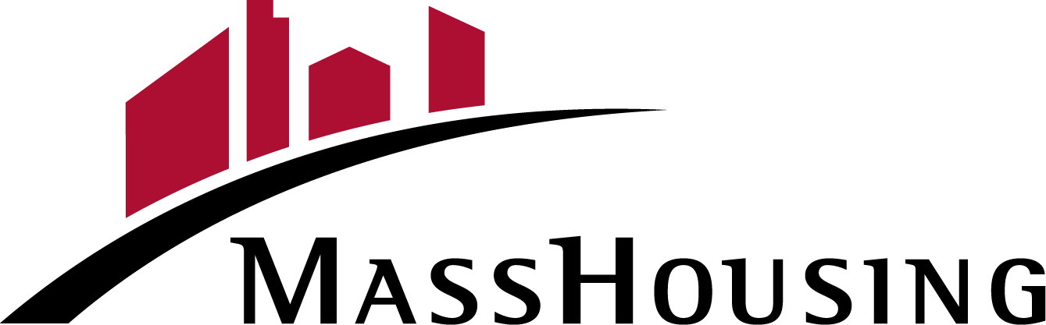

WFA Workforce Advantage
Certification of Zero Income

Name: Address: City: Zip Code:

I certify that I do not individually receive income or have not received income from any of the following sources for the period through .

- Wages from employment (including commissions, tips, bonuses, fees, etc)
- Income from operation of a business
- Rental income from real or personal property
- Unemployment or disability payments
- Public assistance payments
- Periodic allowances such as alimony, child support, or gifts received from persons not living in my household
- Social Security payments, annuities, insurance policies, retirement funds, pensions, or death benefits
- Veteran's Benefits
- Supplemental Security Income
- Any other source not named above

Under penalty of perjury, I certify that the information presented above is true and accurate. I understand that providing false representations herein may constitute an act of fraud. I acknowledge the information provided is being used for the specific purpose of determining whether my household meets MassHousing income limits. I will fully cooperate with the lender to provide or obtain any necessary documents to confirm the information given.

Date:
Signature

Print Name

WFA Workforce Advantage Certification of Zero Income– MassHousing HomeOwnership Form L-107WFA
April 19,2022

Page 1 of 1

