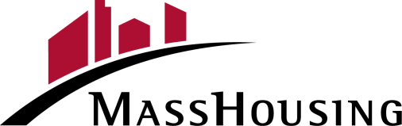

**ENERGY SAVER HOME LOAN PROGRAM**

**BORROWER COMPLETION AND CONSENT FORM**

|  |  |
| --- | --- |
| **MassHousing Loan Number:** |  |
| **Borrower Name:** |  |
| **Property Address:** |  |
| **Contractor Name:** |  |

The energy improvements to the above-mentioned property have been completed in a workmanlike manner to my/our satisfaction.

I/We certify that:

1. The loan proceeds have been spent only on eligible property energy improvements.
2. The property energy improvements have been completed in accordance with the work estimate.
3. I am satisfied with the work.
4. I/We request that the final release of funds from the Escrow Account be made to both the borrower and the contractor after you receive an acceptable Final Inspection Report.
5. Amount to be disbursed: $______________________________________________________

Comments: _____________________________________________________________________________________

_____________________________________________________________________________________

_____________________________________________________________________________________

_____________________________________________ _______________________

**Borrower Signature Date**

**_____________________________________________ _______________________**

**Borrower Signature Date**

***Instructions: Please submit this form to MassHousing to request payment to the contractor upon final completion of the project.***

_____________________________________________________________________________________

**Energy Saver Home Loan Program Borrower Completion and Consent - MassHousing -Home Ownership**

**Page 1 of 1 4/29/2024**